Please find below step by step instructions to build a paper rocket and cardboard rocket launcher. A video to accompany this guide can be found at https://rafyouthstem.org.uk/resource/raf-stem-at-home-rocket-launcher-challenge
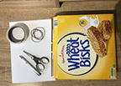 | - For this project you will need:  A Cereal box or 3 pieces of A4 card.  2 pieces A4 paper  Scissors  4 elastic bands  Sellotape  Pencil or pen
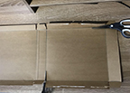 | - Open and flatten your cereal box carefully and cut out the front, back and sides.
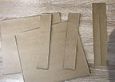 | - You should end up with 2 large pieces of card (front and back of your box), 2 thin strips of card (sides of your box) and some spare pieces from the top or bottom of the box.
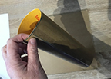 | - Roll one of the large pieces into a cylinder shape and stick with Sellotape. This will be your OUTER launch tube.
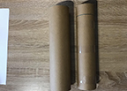 | - Roll the other large piece into a smaller cylinder, stick with sellotape and mark a line approx. one inch from the top all the way round your tube. This will be the INNER launch tube.
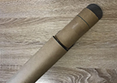 | - The INNER launch tube MUST be able to slide up and down the inside of the outer launch tube without getting stuck anywhere. Test it now and adjust if required.
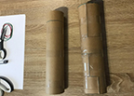 | - Take the thin strips of card and wrap one around the middle and one around the bottom of your OUTER launch tube. Stick them in place with Sellotape. This reinforces the bottom of your tube and provides a stronger area for you to hold in the middle of your tube when launching your rocket.
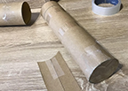 | - Take the spare bits of card and Sellotape them to the bottom of your INNER launch tube so that you cover the hole at the bottom of the tube. Leave the top of your tube open.
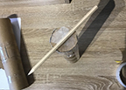 | - Sellotape a pencil or pen to the bottom of the INNER tube. Make sure the pencil is taped securely!
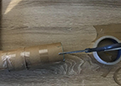 | - Take your OUTER launch tube and cut 2 small slits approx. 2 cm apart and 1.5 cm deep on one side at the top of the tube. Repeat on the opposite side of the tube so you end up with 4 slits.
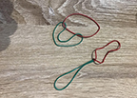 | - Take your rubber bands and loop them together to make a band that will pull down to fit the length of your launcher. (You might only need one band – you might need 3 – depends on the length of your tube)
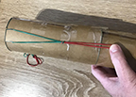 | - Hook one end of the elastic bands through the slits at the top of the OUTER launch tube. Repeat on the other side. If your card bends to much when you pull on the elastic band you can reinforce the top with Sellotape or you might need to add an extra band to the length.
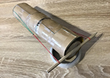 | - Insert the INNER launch tube into the OUTER launch tube and loop the elastic bands around the pencil. You should now be able to hold the OUTER launch tube in the middle and pull the INNER launch tube down using the pencil against the resistance of the elastic bands. Remember the blue line we drew on the INNER tube? Don’t pull the INNER tube down past this line or the INNER tube might pop out! Once you have pulled the INNER tube down keep hold of the OUTER tube and let go of the INNER one. It should snap back inside the OUTER tube using the energy stored in the pulled elastic band.
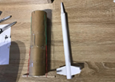 | - Next you can make your paper rocket. The body of the rocket can be made by rolling a piece of A4 paper into a tight tube (must be able to fit easily into your INNER tube. The nose cone can be made by rolling a square of A4 paper into a cone and sellotaping it to the top of the body. Have fun playing around with different nose cone shapes to see what works and looks the best.
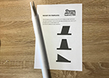 | - To help your rocket fly attach some fins to the bottom. We have provided you with some templates but please have fun experimenting with your own designs. Fins help to stabilise a rocket when in flight.
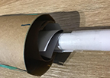 | - Last, but not least, load your paper rocket into the INNER launch tube (folding your fins carefully if required).  - Make sure you have a safe and clear space in front of you; pull down your INNER tube whilst holding the OUTER tube and LAUNCH!

