To save your own copy of this doc, click File at the top left, then select Make a copy.
To save a copy to your computer, select Download.
Teacher Accounts
Create your Teacher Account, make classes,
and add students

Creating your teacher account
Visit this link to get started: https://scratch.mit.edu/educators/register
You’ll be prompted to create a username and password.
Make sure that your username does not contain your name or personal information, like your school, location, or email address.
Within the Scratch community, all users are asked to refrain from sharing personal information through their usernames. It’s important that both you and your students follow these guidelines. Accounts that do not adhere to these guidelines will be deleted.

Creating your teacher account
Tips for making your username

- Incorporate the name of the subject you teach
- ex: QuirkyArtTeacher

- Use a tool or term from the subject you teach
- ex: MetamorphicRocks

- Add an important date, to create a unique username
- ex: Bibliophile1440

- Make it memorable with a pun or an alliteration!
- ex: TyranoTeacher
Be sure to make a note of your username and password.
 | - Click through each step to complete registration.
- Log into your email, and confirm your email address.
- Check your spam folder if you do not see the email.
- Once you have confirmed your email address, we’ll review your account.
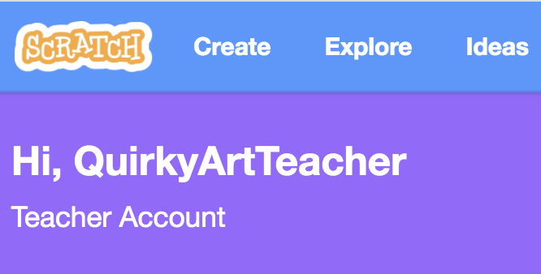 | - Once your account has been reviewed, you’ll receive a welcome email. Click the button to confirm your email address.  - Now you can log into your teacher account at scratch.mit.edu!

Creating Classes
Creating classes allows you to manage groups of students, and create studios where your students can add their projects.

Creating Classes
- Once you’ve successfully logged into your Teacher Account, there will be a bar at the top of the screen with three options.
- Select My Classes.
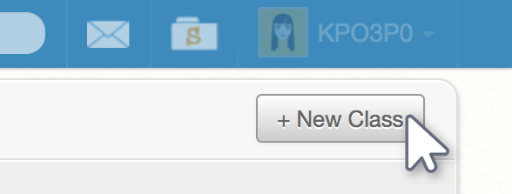 | - To create a class, click the + New Class button at the top right of the page.  - Enter the class name and description.  - Do not include real names and locations, like the name of your school or city/town.
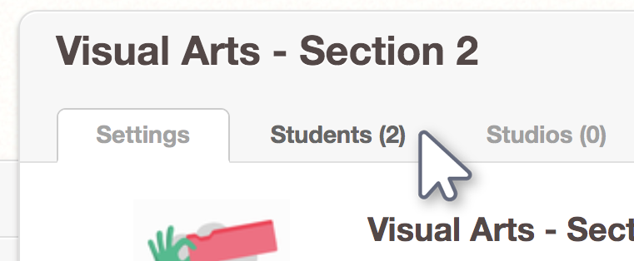 | - Once you’ve created a class, you can add students.  - Click the Students tab to begin adding students.

Adding Students
There are three ways to add students to your class. The following three tables will guide you through each method. The first method allows you to add an individual student to a class. Methods 2 and 3 allow you to add multiple students to a class.

Method 1: Adding Individual Students
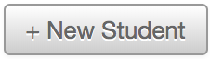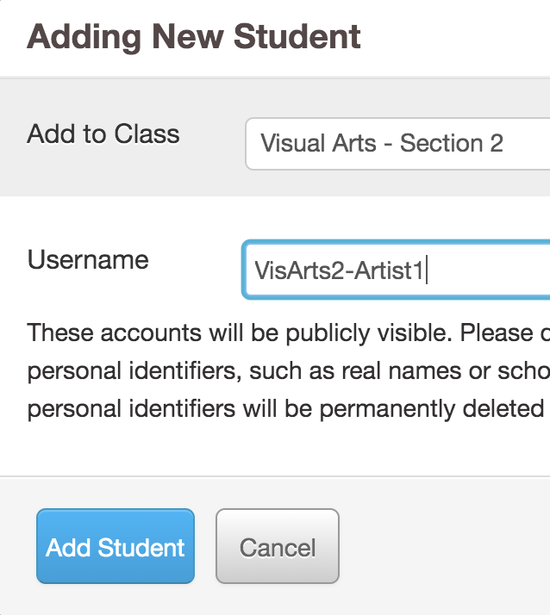 | - Click + New Student to add students individually.  - You will be prompted to create a username for this student.  - Make sure that the usernames you create do not contain identifying information about yourself, your students, or your school.  - The password for this student username will automatically be set as your username  for your teacher account.  - Have students log into their accounts and change their passwords.

Tip: Create a naming convention as a guideline for generating usernames. For example, you may want each name to include an abbreviation for the course name, the class section, and the student’s number on your roster (ex: VisArts-02-17).

Use this sign-up sheet template to record your usernames and the students they correspond to.

Method 2: Student Sign-up Link
Create a sign-up link which allows students to create their own usernames and passwords
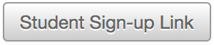 | - Clicking the Student Sign-Up Link button will generate a link which will allow your students to join the class you’ve just created.
- Share this link with your students.
When they access it, they will be prompted to create their own username and password.
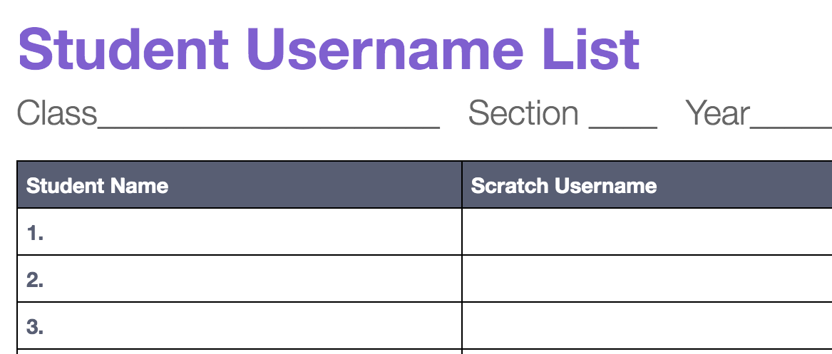 | - Use the sign-up sheet we’ve created to record the usernames and passwords your students have created. Sign-Up Sheet

Method 3: CSV Upload
Create usernames and passwords for all of your students at once using a spreadsheet
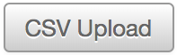 | - Click the CSV Upload button on the class page.
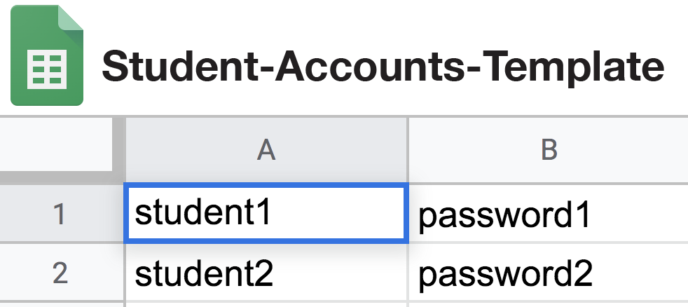 | - Using the template provided, create a username and password for each of your students. Download the template here.  - You’ll need to download this Google Sheets doc from Google as a CSV (File > Download > .csv)
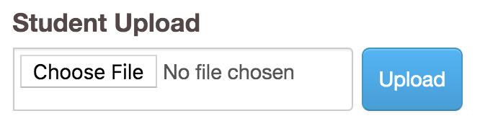 | - Once you’ve created usernames and passwords for each student, click CSV Upload, to upload your file.  - Your student accounts will appear under the Students tab for the class.

Created by the Scratch Team (scratch.mit.edu) and shared under
the Creative Commons Attribution-ShareAlike 4.0 International Public License (CCbySA 4.0).
| | | | | | | | | | | COLOR SCHEME

