RAF Code Commander: Cosmic Launch Project Overview
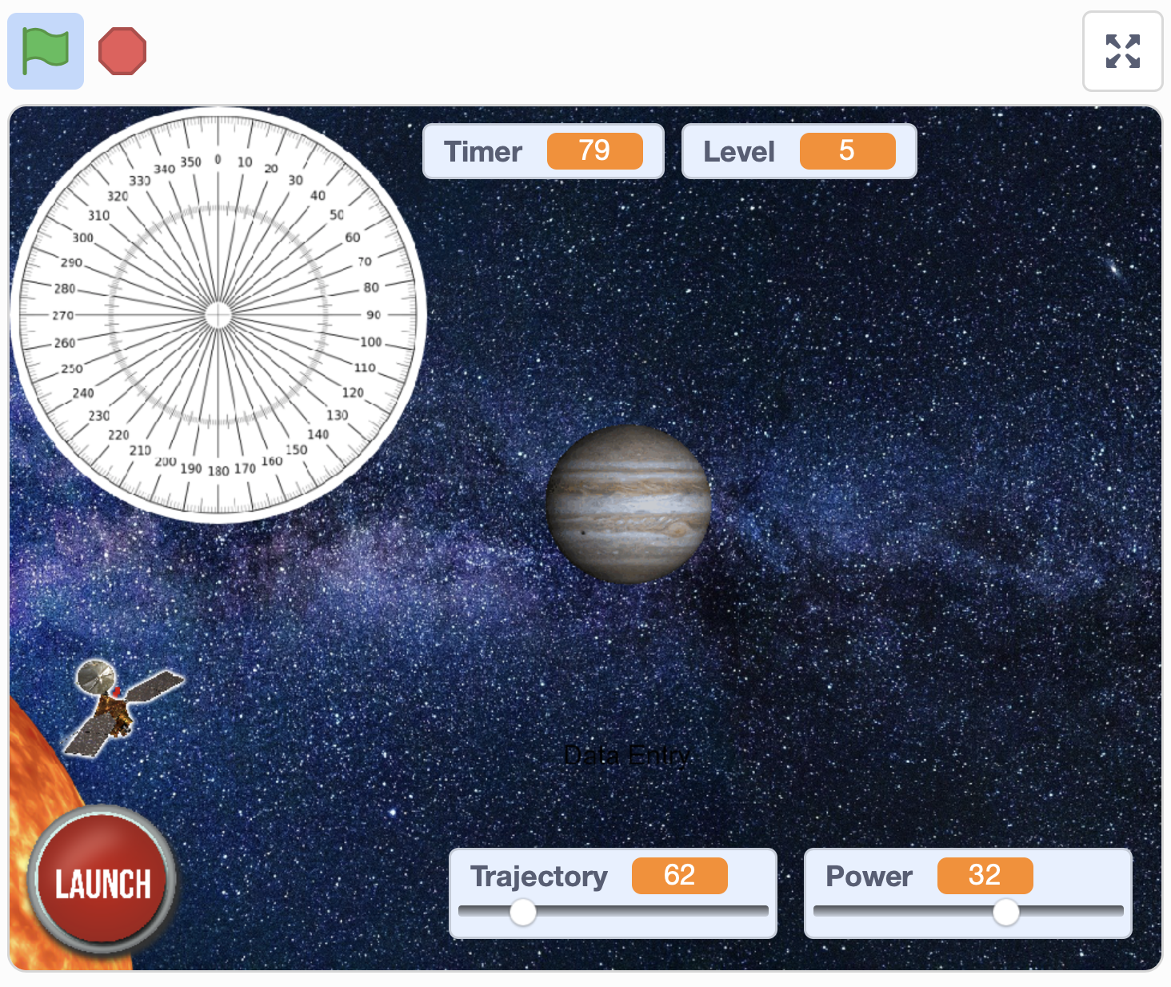
In this project, students use the online version of Scratch 3 to create a simple game in which the player enters a trajectory and an engine power to fly a probe from The Sun to each of the eight planets in our Solar System, in turn. In addition to developing understanding of a range of programming / computer science principles, students will compare and contrast the details of the project with the realities of planning a real interplanetary mission. They will discuss and explore the many ways in which their Scratch project is unrealistic, and consider the implications for scientists in planning for missions to other planets, including future crewed missions to Mars.
Completed project example with annotations / comments: https://scratch.mit.edu/projects/425127673

Logistical / System Requirements
- Scratch provides a free, online programming interface. To use Scratch, students will need Scratch accounts.
Please note that internet access is required for both session leaders and students throughout this project.

Please check in advance of any sessions that computers or devices can access all necessary websites, especially the Scratch website (for students) and the Scratch site and YouTube (for session leaders).
- Scratch provides free Teacher accounts, and we recommend that these are used by session facilitators, where possible. Instructions for how to apply for a Teacher account are included in the resources for this project. Following those instructions, please submit a teacher account to the Scratch team at least two weeks before your first session with students, as approval for teacher accounts is handled manually by the Scratch team. Once approved, a teacher can create multiple accounts for students to use. These accounts do not require an associated email address. A template to record student usernames and passwords is included in the resources for this project. Further information on Scratch for Educators can be found at https://scratch.mit.edu/educators.
- Alternatively, individual accounts can created manually by visiting scratch.mit.edu and clicking ‘Join Scratch’ on the top navigation bar. A user will then be prompted to create their own username and password. Note that manual account creation requires that each account has an associated email address. You may wish to encourage parents or carers to work with their children to create accounts, using parental email addresses.
- Irrespective of whether teacher-created or manual accounts are used, students should have parent or carer permissions in place to use Scratch online. A template text for a parental permissions letter is included in the session resources. This text can be edited to accommodate either the use of Teacher accounts, as above, or to encourage parents to work with their child to create individual accounts.
- Scratch requires a recent version of Chrome (Windows / Chromebook), Microsoft Edge (Windows), or Safari (Mac) to run properly. Do not attempt to use Scratch in the older Windows browser Internet Explorer, as it will not function properly. (Many adults and students almost instinctively launch Internet Explorer when asked to “open the internet”).
- Scratch also works in Safari when running on a recent version of iPadOS on an iPad. Please note that some aspects of using Scratch on the iPad are potentially tricky or frustrating for students. In particular, students need to be careful when constructing and rearranging code into algorithms, and to not accidentally move items around the Stage area. The use of Scratch on an iPad can be improved by connecting a Bluetooth mouse to an iPad. For this to work properly, please update your iPads to at least iPadOS 13.4, as Apple dramatically improved iPad support for mice in Spring 2020. We strongly recommend against trying to code in Scratch on an iPad mini, as the screen size is too small for this to work well.
- At the end of each session, there is a link to an optional Kahoot Quiz, to check student knowledge and understanding. To use these, the session leader(s) will require a free Kahoot account. Go to create.kahoot.it to create accounts. Students will not require any accounts: they will login to the quizzes using a unique code provided to the session leader when a quiz is started. (As an alternative to using the direct links to Kahoot Quizzes in the presentation, teachers can click onto the ‘Discover’ tab, and search for ‘RAF Scratch Project’ to find each quiz).

Other notes:

- Slides within the presentation are colour-coded to indicate the main theme of a slide / activity:
  - Red border: slide is predominantly focused on computer science / coding content
  - Blue border: slide is predominantly focused on space science / space travel content
  - No border: introductory slides / slide relates to both computer science and space science
  - These indicators are intended to allow session leaders to modify delivery to students according to their needs and the context of the project. A computing teacher, for example, may wish to focus more on the coding / computer science aspects, while a science teacher may wish to focus on the space aspects. Alternatively, the project might be divided between two facilitators, one focusing on the space content, another on the computing.
- Slides within the presentations include presenter notes to provide additional information and context to presenters. Please be aware, the PDF files do not include these notes. Presentation notes are viewable beneath the slides in Powerpoint when in ‘Normal’ view or ‘Outline’ view. Presenter notes include additional information on:
  - The main ideas in the slide
  - Common misconceptions that students might have about the topic of the slide
  - Other interesting questions / stories / observations which you may wish to discuss with students

National Curriculum Links - Computing

Key Stage (Year Group) | National Curriculum Statement(s) | Project Session Ref.
Key Stage 2  (Years 3 to 6) | Pupils should be taught to:  - design, write and debug programs that accomplish specific goals, including controlling or simulating physical systems; solve problems by decomposing them into smaller parts  - use sequence, selection, and repetition in programs; work with variables and various forms of input and output  - use logical reasoning to explain how some simple algorithms work and to detect and correct errors in algorithms and programs | These objectives are relevant throughout the coding parts of the project.  The key vocabulary terms are introduced in the following sessions:  - Algorithms – Session 1 – from Slide 7  - Sequence – Session 1 – from Slide 13  - ‘Decomposing them into smaller parts’ (Decomposition) – Session 1 – from Slide 25  - Repetition (Iteration) – Session 1 – from Slide 33  - Variables – Session 2 – from Slide 8  - Selection – Session 3 – from Slide 17  Logical reasoning and detecting and correcting errors (debugging) are incorporated into a number of the tutorial videos, including through ‘pause and discuss’ points.
Key Stage 3  (Years 7 to 9) | Pupil should be taught to:  - design, use and evaluate computational abstractions that model the state and behaviour of real-world problems and physical systems  - … use logical reasoning to compare the utility of alternative algorithms for the same problem | In addition to reinforcing and deepening understanding of the Key Stage 2 National Curriculum statements, the additional Key Stage 3 objectives are relevant throughout the coding parts of the project:  - In the project, students work with a ‘model’ of the solar system, and are asked to discuss and evaluate how realistic (or otherwise) it is.  - Logical reasoning and a comparison of alternative algorithms is incorporated into a number of the tutorials videos, including through ‘pause and discuss’ points.

National Curriculum links - Science

Key Stage (Year Group) | National Curriculum Statement(s) | Project Session Ref.
Key Stage 2  (Year 4) | Sound:  Pupils should be taught to:  - identify how sounds are made, associating some of them with something vibrating  - recognise that vibrations from sounds travel through a medium to the ear | - “There is no sound in space” - Session 4 – Slides 22 and 23
Key Stage 2  (Year 5) | Earth and Space:  Pupils should be taught to:  - describe the movement of the Earth and other planets relative to the sun in the solar system  - describe the movement of the moon relative to the Earth  - describe the sun, Earth and moon as approximately spherical bodies  Forces:  - identify the effects of air resistance, water resistance and friction, that act between moving surfaces | - The planets of the Solar System:  - Session 1, Slides 20 to 22  - Session 3, Slides 8 to 9, Slide 12  - Session 4, Slides 8 to 9, Slide 12  - Session 5, Slides 8 to 11  - The Apollo launches and missions to The Moon – Session 2, Slides 20 and 21, Session 3, Slides 10 and 11  - “How realistic is our game?” – Session 2, Slide 28  - Friction / air resistance (the heating effect of entering the atmosphere of The Earth or Mars – Session 5, Slide 9
Key Stage 3  (Years 7 to 9) | Subject content - Physics:  - our sun as a star, other stars in our galaxy, other galaxies  - the light year as a unit of astronomical distance  Sound waves  - sound needs a medium to travel, the speed of sound in air, in water, in solids  - sound produced by vibrations of objects, in loudspeakers, detected by their effects on microphone diaphragm and the ear drum; sound waves are longitudinal | In addition to reinforcing and deepening understanding of the Key Stage 2 National Curriculum objectives, learning of additional Key Stage 3 curriculum statements are supported in the following sessions / slides  - Our sun as a star, The Milky Way, scale of The Universe – Session 4, Slides 9 to 13  - The meaning of a ‘light year’ – Session 4 – Slide 12 (including in the ‘The Powers of Ten’ video clip).  - “There is no sound in space” - Session 4 – Slides 22 and 23

Other possible curriculum links:
- Mathematics: angles
- History: the Space Race, Apollo missions, changes in society regarding the roles of women and racial diversity since the 1960s (through discussion of changes in the standard ‘profile’ of astronauts).

Session overviews

Session Number | Computer Science  Learning Objectives / Key Vocabulary | Space Science  Learning Objectives | Session overview: key activities | Resources
1 | - What is an algorithm, and how are they represented in Scratch?  - Using iteration (repetition) in coding  - Understand that, when working on coding projects, we need to break down projects / problems into a series of smaller problems (decomposition) | - The names, order from The Sun, and approximate relative sizes of the planets in The Solar System | - Explore / remember what an algorithm is, using real world examples.  - Learn the basics of the Scratch interface, including how to create new Scratch projects, and how to open and save the provided Scratch template, and to save it into your Scratch online user area.  - Recall / learn the names of the eight planets in order, using the Scratch template costumes to remind, if required. Use the Scratch template is check facts and understanding. Watch ‘The Planets’ video clip, if deeper exploration of topic required.  - Watch a video clip of the completed project to create an overview of the key elements in the project.  - Learning to get the probe moving:  - Setting the angle for movement  - Comparing the movement with single ‘move’ command to using iteration to make smaller (smoother) movements. (Using prediction with provided code samples prior to coding and testing).  - Review meaning of ‘iteration’. | - Session 1 Powerpoint presentation  - Starter template for creating the  game : https://scratch.mit.edu/projects/419026147  - Video clip: ‘Session 1 - An Introduction to Scratch’: https://youtu.be/uBUU4j9gsFA  - Video clip: The Planets (National Geographic) - https://youtu.be/libKVRa01L8  - Video clip: ‘Session 1 - Gameplay Demo’ of the completed project: https://youtu.be/QhOCT0MfLoI  - ‘Session 1 - Analysing gameplay handout PDF’ – handout of questions for students to use when reviewing gameplay video  - Video clip: ‘Session 1 - Getting the probe moving’: https://youtu.be/Ml_aPduxKeo  - Kahoot quiz: https://create.kahoot.it/v2/share/raf-code-commanders-session-1-quiz/a5668a3b-e843-4c90-abe2-e05307ae69a2
2 | - What is a variable?  - Using the ‘broadcast’ command in Scratch. (Broadly similar to the concept of a subroutine in computer science). | - Launching a rocket into space.  - Discussing and collating ways in which students think that the project is a realistic / unrealistic model of how a real probe would work:  - Scale of planets  - Scale of distances  - Planets are moving in The Solar System  - Parabolic trajectories (impact of gravity) | - What is a variable? Discuss examples from a range of computing contexts, including gaming. Relate to the variables they’ve already used in the Scratch project (trajectory and power).  - Learning to link the ‘Launch’ button to the movement of the probe using the ‘broadcast’ command.  - What is involved in launching a rocket? Some facts and a video clip of Saturn V  - Learning to build an algorithm which ‘resets’ the Scratch project when the green flag is clicked: moving the probe back to the start point, resetting trajectory and power etc.  - Working in pairs / small groups to consider ways in which the project is realistic, and (very) unrealistic. | - Session 2 Powerpoint presentation  - Video clip: ‘Session 2 - What is a variable?’: https://youtu.be/pDzp1bwgWds  - Video clip: ‘Session 2 - Linking the Launch button’: https://youtu.be/libKVRa01L8  - Video clip: ‘Session 2 - Resetting the probe’: https://youtu.be/l96bMvu_JhE  - Video clip: “Apollo 11 Launch”: https://youtu.be/S3ufJ7lcr08  - Kahoot quiz: https://create.kahoot.it/v2/share/raf-code-commanders-session-2-quiz/23b15155-a6b5-4159-9494-a12ec2b35278
3 | - Using selection to make code blocks run when certain criteria are met. | - Learning / recalling information about the scale of The Solar System | - Reviewing ideas about what is realistic / unrealistic about our ‘simulation’, using video clips.  - What happens when the probe hits a planet in our Scratch simulation? Using broadcast commands and the level variable to move through the levels and change the target planet each time. | - Session 3 PowerPoint presentation  - Video clip (National Geographic) - ‘Watch This Guy Build a Massive Solar System in the Desert’: https://youtu.be/Kj4524AAZdE  - NASA video clip: ‘Maven: Targeting Mars’: https://youtu.be/UmcdhK_Bc9I  - Video clip: ‘Session 3 - If … then’: https://youtu.be/tNQ_XLLlVCw  - Video clip: ‘Session 3 - Moving through levels’: https://youtu.be/3sChVGDdFyI  - Kahoot quiz: https://create.kahoot.it/v2/share/raf-code-commanders-session-3-quiz/7756db4d-d494-4c8b-b43d-6730b59f1296
4 | - Use previous knowledge of selection and iteration to complete the space probe game | - Beyond our Solar System: what is beyond Neptune? What is the distance to the nearest star? (other than The Sun)  - How big is the observable Universe?  - What are the journey times with current rocket tech?  - Why is space silent? | - Review journey times from The Earth to each of the eight planets. How long would it take to fly to the nearest star? (other than The Sun).  - What happens if we touch the edge of the stage? Creating an ‘explosion’ algorithm, and linking that with ‘broadcast’ command.  - Coding: What happens if we succeed in reaching all of the planets? (Creating the ‘well done’ message  - Coding: Adding a time  - What is wrong with space movies? (There is no sound in space)  - Coding adding sound effects.  - Testing / playing completed projects  At the end of this session, the students have complete, functional games.  In session 5, students will explore ways of extending / enhancing their programs. | - Session 4 PowerPoint presentation  - ‘Scales of the universe in Powers of Ten’ video clip - https://youtu.be/44cv416bKP4  - Video clip: ‘Session 4: Creating a crash algorithm’: https://youtu.be/lMruEuZQ1rg  - Video clip: ‘Session 4: What happens when the player completes the game?’: https://youtu.be/PuEVDkZJGzc  - Video clip: ‘Session 4 - Adding a timer’: https://youtu.be/tx0Ohc2m21A  - Video clip: ’The Death Star Destroys Alderaan - Star Wars: A New Hope’ - https://youtu.be/5p0IP-FVG2I  - Video clip: ‘Session 4 - Adding sound effects’: https://youtu.be/CGpscewDWj8  - Kahoot quiz: https://create.kahoot.it/v2/share/raf-code-commanders-session-4-quiz/b85053b5-c3ca-4ee1-b697-2e539ae01aa8
5  (Extension activities) | - Extension projects:  - Using the pen tool to trace the path taken by the probe  - Adding a ‘best time’ variable to keep track of the best time to complete the game so far.  - Modify the speed of the probe as it flies to slow it down, and add algorithms that check whether the probe is travelling too quickly when the probe touches a planet. | - What are the implications if what we’ve learned for travelling to other planets for human beings? | - Discuss the implications of what we’ve learned for travelling to Mars, and whether they would like to be involved in the first mission there?  - Present students with three extension projects to add to their code, with sample code snippets for each:  - 1. (Easier) Using the pen tool to add a path behind the probe, clear that path for each launch, and change the colour of the path for each launch.  - 2 (Harder) Adding a way to record the ‘best time’ to complete the game, so players can compete against one another.  - 2. (Trickiest) Modify the speed of the probe as it moves through space to make it slow down. If the probe is still moving too quickly when it reaches the planet, make it explode.  - Students share and test completed projects. | - Session 5 PowerPoint presentation  - Video clip: ‘Apollo 13 Rocket Re-entry and splashdown scene’: https://youtu.be/A83anvGUrCs  - Video clip: ‘The Challenges of Landing Humans on Mars’ - https://youtu.be/SC_CsRDAFok  - Video clip: ‘What exactly does space travel do to your body?’ - https://youtu.be/siL97hz8o2w  - Video clip: ‘How Space is bad for your body’ - https://youtu.be/jp6snBzrMUA  - ‘Session 5 - Extension code handout PDF’ Printable PDF of code snippets and quick tips for extension activities  - (For reference) A version of the completed game, with all extension algorithms added - https://scratch.mit.edu/projects/424949469  - A support video for facilitators in implementing these enhancements can be found at https://youtu.be/ct6unftsHUo

Licensing and credits information:

- Planet and Sun images - pixabay.com: labelled for free, unrestricted use
- Voyager One probe image - Public domain (NASA) - https://en.wikipedia.org/wiki/Voyager_1#/media/File:Voyager_spacecraft_model.png
- Space X Falcon 9 image - https://commons.wikimedia.org/wiki/File:Launch_of_Falcon_9_carrying_CRS-6_Dragon_(17170624642).jpg, used under a Creative Commons CC0 1.0 Universal Public Domain Dedication
- Proxima Centauri image - https://commons.wikimedia.org/wiki/File:New_shot_of_Proxima_Centauri,_our_nearest_neighbour.jpg, used under a Creative Commons Attribution 4.0 Unported license
- The Apollo Lunar Module - https://commons.wikimedia.org/wiki/File:Apollo16LM.jpg: used under a Public domain license
- Astronaut images from NASA. Not subject to copyright (www.nasa.gov/multimedia/guidelines/index.html)
- The relative sizes of The Sun and planets - https://commons.wikimedia.org/wiki/File:Planets2013.svg: used under the Creative Commons Attribution-Share Alike 3.0 Unported license.
- Apollo 11 launch - https://commons.wikimedia.org/wiki/File:Apollo_11_Launch_-_GPN-2000-000630.jpg: used under a Public domain license
- Compass image - Images used from Wikimedia Commons: Used under a Creative Commons Attribution-Share Alike 3.0 Unported License.
- Space explosion image - https://www.needpix.com/photo/774026/earth-globe-explosion-collapse-setting: used under a Public Domain license
- Music (Gameplay Demo video): ‘New Dawn’ from BenSound.com - used under a free license with attribution

Disclaimer: Included in this project are links to YouTube videos and other websites selected to support learning outcomes for students. These links and media have been checked for their suitability at the time of publication. The RAF and Hyett Education are not responsible for the content of any additional media or webpages shared by publishers, and do not endorse any services or products that they sell.

The RAF and Hyett Education are also not responsible for, and do not endorse, any adverts, comments or links appearing alongside or within media, including any associated with video materials on YouTube. We recommend that YouTube is used in a ‘logged out’ state, to minimise the risk that any advertisements that are shown are associated with the previous viewing history of the PC or facilitator that is leading the session. For information on signing in and out of YouTube, visit https://support.google.com/youtube/answer/3802431. The content of third-party links may change over time. We recommend that project facilitators carefully review media and third-party links before sharing them with students.

